EXPERIMENT -8
EXP NO 8: CREATE A VIRTUAL MACHINE WITH 1 CPU, 2GB RAM AND 15GB STORAGE DISK USING A TYPE 2 VIRTUALIZATION SOFTWARE.
DATE: 13-02-2026
AIM: To create a virtual machine with 1 cpu, 2gb ram and 15gb storage disk using a type 2 virtualization software.
PROCEDURE:
STEP 1: Download VMware workstation and installed as type 2 hypervisor.
STEP2: Download ubuntu or tiny OS as iso image file.
STEP 3: In VMware workstation->create new VM.
STEP 4: Do the basic configuration settings.
STEP 5: Created tiny OS virtual machine.
STEP 6: Launch the VM.
IMPLEMENTATION:
Step 1: Download VM ware Workstation and Installed as Type 2 Hypervisor
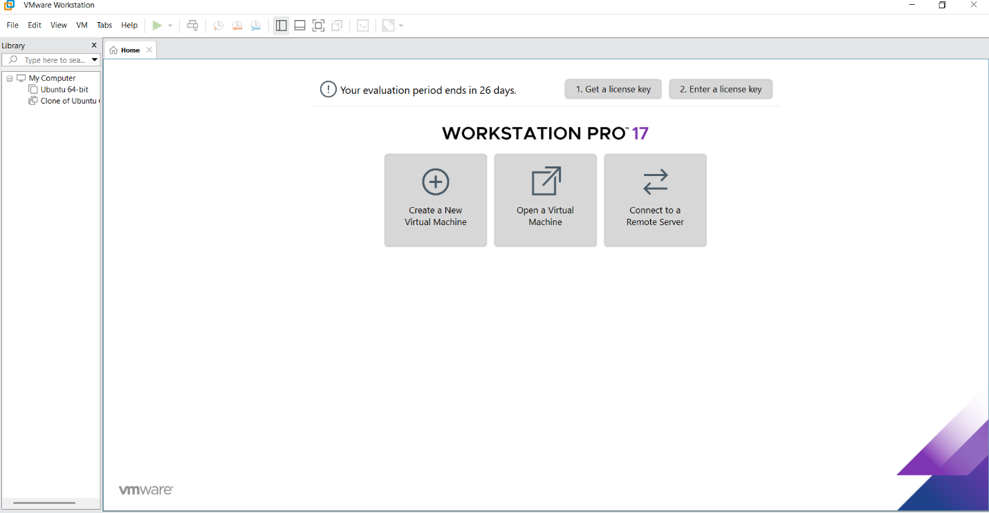
Step 2: In VMware Workstation->Create New VM
Step 3: Do The Basic Configuration Settings.
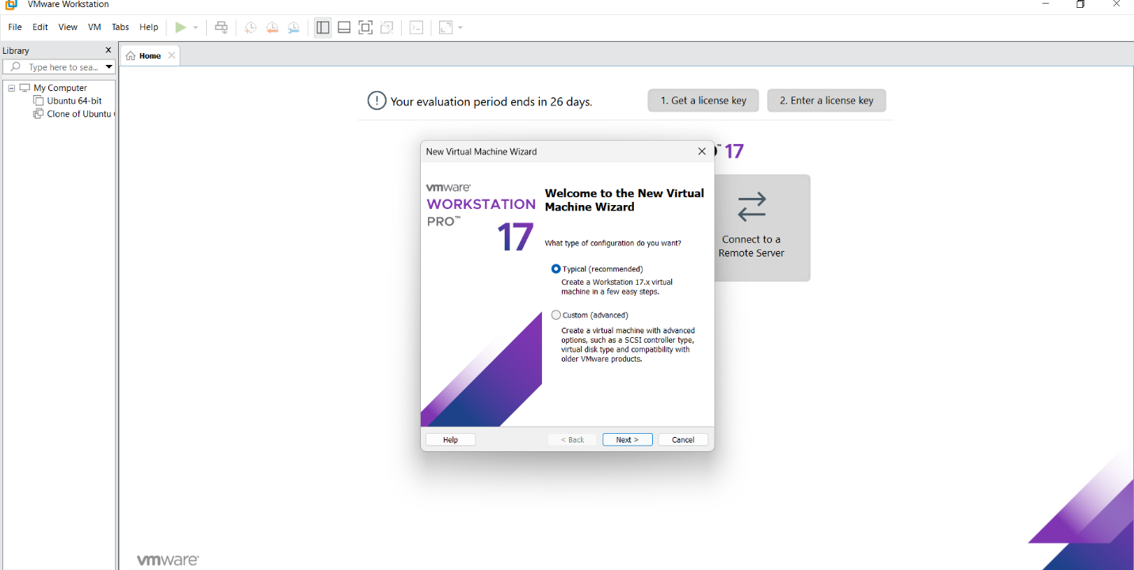
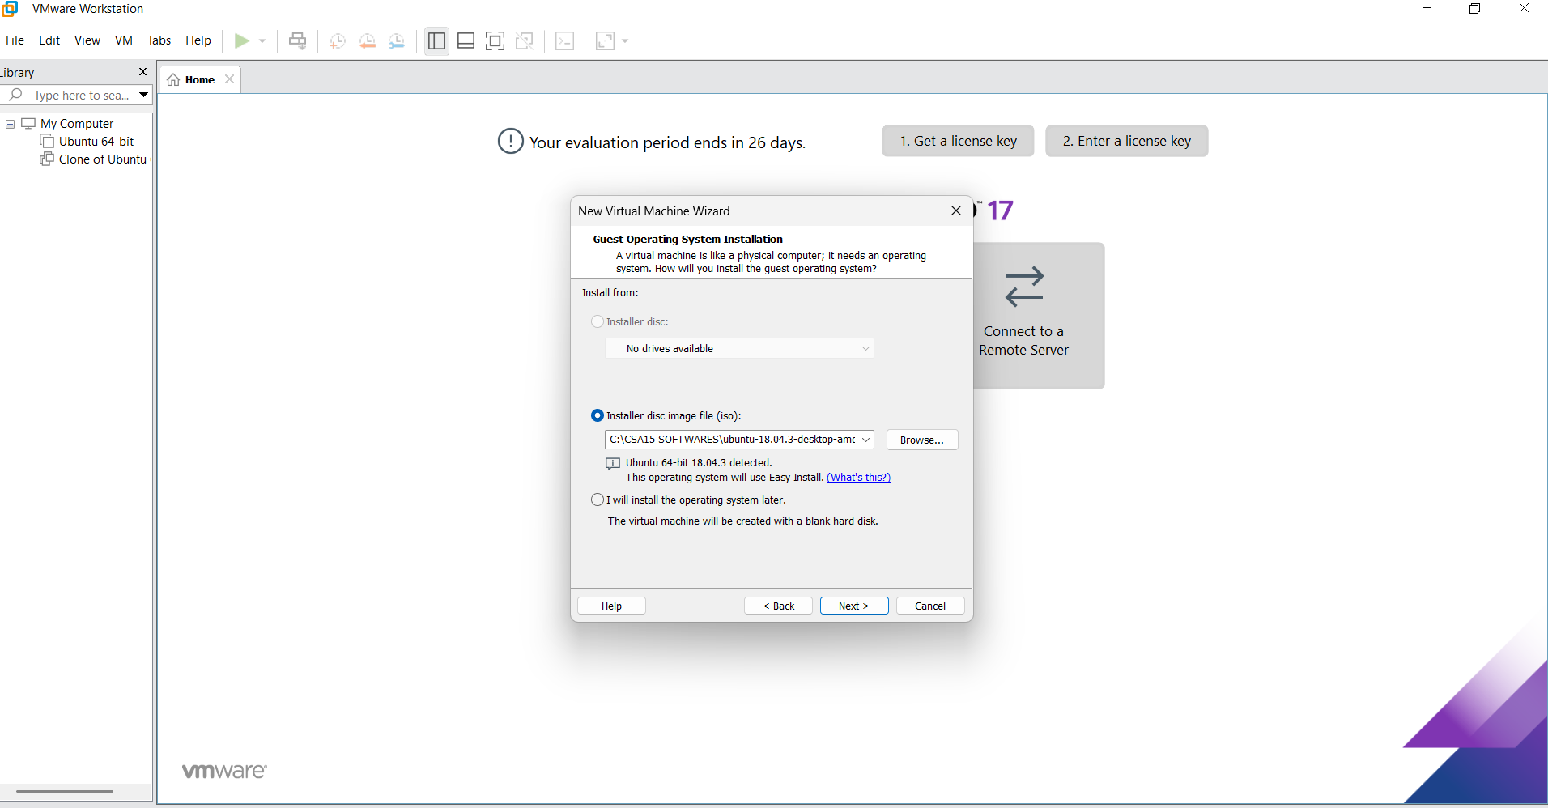
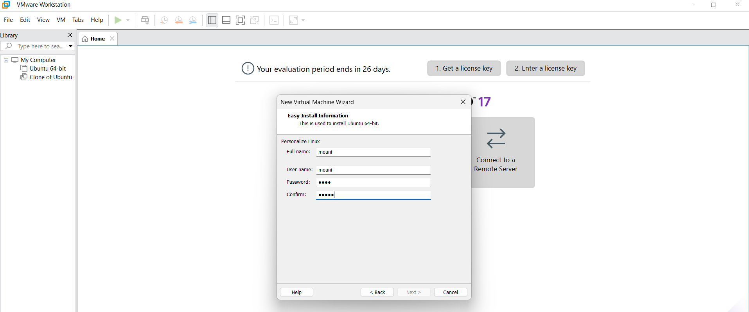
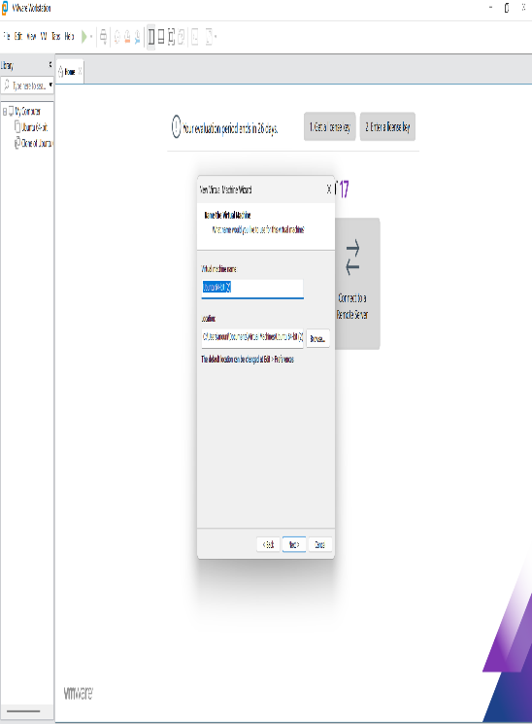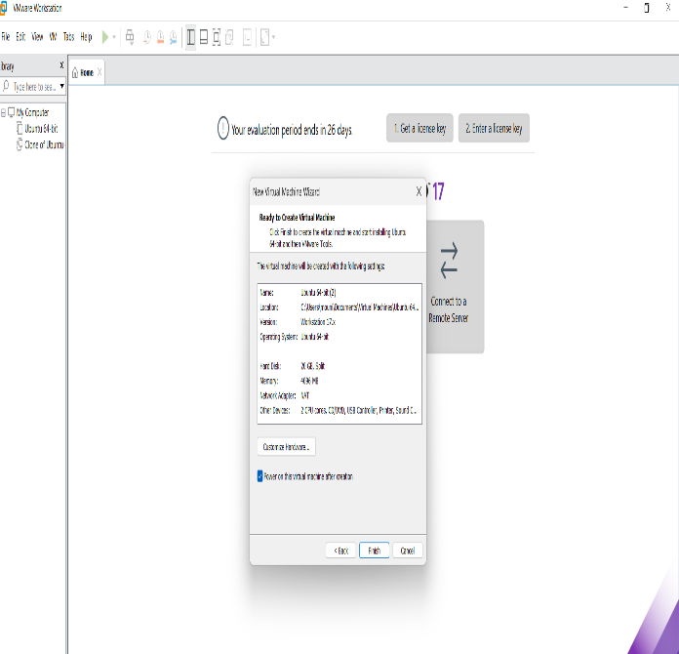

Step 4: Created Tinyos Virtual Machine
